# Hu3a Trustees Meeting 5

Date | time Friday 16th July 2021@ 12 noon Location zoom

|  |  |  |  |  |  |  |  |  |  |  |  |
| --- | --- | --- | --- | --- | --- | --- | --- | --- | --- | --- | --- |
| |  |  | | --- | --- | | Meeting called by | Lesley Metcalfe | | Type of meeting | Committee meeting | | Secretary | ~~Barbara Lavender~~ | | Minutes | Lesley Metcalfe | | Zoom manager | ~~Peter Tatam~~ | | **Attendees** (Apologies received): David Campos, Caroline Choat, Wendy Foster, ~~Barbara Lavender~~, Lesley Metcalfe, Dilwyn Roberts, Gerry Sexton, ~~Peter Tatam~~, Mark Pollington  **Documents attached**: [Please read]  Minutes of last meeting, documents submitted for this meeting, |
| Zoom link: | Web [https:/www.haverhillu3a.com](https://www.haverhillu3a.com) |

|  |  |  |  |  |  |  |
| --- | --- | --- | --- | --- | --- | --- |
| 1 | Minutes of previous meeting approved as correct | sign and send to BL and upload to website | | Lesley  asap | | |
| 2 | Matters arising from minutes of 17.06.2021  Finance authorisations for bank now completed.  Meet the Chair was a successful event.  ‘Do you remember this?’ project in progress. | Web project | Gerry et al. | | |
| 3 | Update on Committee, Constitution, Policy and documents:  Roles document assumed final and uploaded.  Risk assessment forms to be circulated and go on website.  Finance Policy documents to complete including a value for our reserve. | Risk assessments  Finance policies | Peter  Dilwyn | |
| 4 | Update on Events:  HAC sign-up day happening tomorrow, all ready.  Monthly speakers, and Open Day being managed well. |  | Caroline et al.  Wendy, Barbara et al. | |
| 5 | Update on Members and Groups: Several members have rejoined and some groups have restarted | none |  | |
| 6 | Update on Website: Gerry is working on getting the Google calendar working and information needs to be kept up to date | keep checking and feedback any changes needed | All | |
| 7 | Budget for Publicity  Asset register/Inventory – we just need a list of what we have, when we bought it, how much it cost, and where it is stored.  Unfortunately, the meeting was cut short, and nothing was decided. | Budget to be produced by the treasurers and presented at a future meeting. | Mark/Dilwyn | | |
| 9 | Time and date of next meeting:  This will be at a venue, time and date yet to be decided and will be chaired by Peter. | Meeting to decide future of Hu3a committee | Peter Tatum | |

# Document for Treasurers’ consideration: including comments by DL and responses by LM

Based on the accounts published for 2019 there was an overall annual deficit of approximately £2000. This was partly due to the general fund subsidizing the social fund events (Christmas Party and 25th Anniversary celebrations).

The total balance fell from £10,200 to £8500 approx.

Typical annual expenditure is approximately £8000 so it would be reasonable to set the reserve at around £4000 as this is the 6-month level recommended by the u3a(TAT).

The level of reserve is intended to prevent a charity’s accounts from falling into the red over the course of a year. It is also expected that the income for the year approximates to the expenditure for the year.

Setting our reserve at £4000 would mean we should expect a year-end balance of approximately £4000, rather than the £8000 we had in 2019.

Thus, I propose that we plan our budget based on the assumption that we **may** spend between £2000 and £4000 over and above our income in 2020. However, without an obvious major expenditure planned, I would suggest that we keep to a maximum overspend of £2000. (It would be unwise to disrupt our regular spending, which usually matches our income quite well.) This should leave us with an expected year-end balance of approximately £6000.

If desired, we could then repeat this process next year, gradually reducing our surplus to a recommended level.

|  |  |  |  |  |
| --- | --- | --- | --- | --- |
|  | **General Fund** | **Budget** |  | **Considerations:**  The income and expenditure for groups should be separately recorded and accounted.  Social events should similarly be separately accounted and self-funding.  Income and costs of membership, TAT magazine, and Beacon need clarifying please.  There are no website costs for the next 3 years.  Zoom costs at £178 pa could be rescinded.  What are the ‘refreshment’ costs? Do we provide free tea and coffee at HAC on speaker days?  If the limit on attendance at speaker days is 200, how is this fair on our 400 members? It would be better to run zoom presentations in parallel to live events to include those who cannot attend HAC, especially if we wish to increase our membership (and income).  Does News and Views really cost £750 pa? How many are we printing now and can we cover this cost as we do the TAT magazine? Members have the email and website options so should reasonably be expected to pay for hand delivery of printed copy.  This leaves £2,100 (highlighted in red) for everything else, effectively the Publicity Budget for the year. |
|  | **from 2019** | **for 2020** |  |
| **Income** |  |  |  |
| Membership | 5,606.50 | 5,700.00 |  |
| Gift aid | 496.59 | 500.00 |  |
| Other | 213.00 | - |  |
| *Total Income* | 6,316.09 | 6,200.00 |  |
| **Expenditure** |  |  |  |
| Third age fee | 1,820.00 | 1,890.00 |  |
| Groups | --- | --- |  |
| Hall Hire | 1,619.32 | 2,400.00 |  |
| Speakers | 923.50 | 960.00 |  |
| Refreshments | 79.80 | 100.00 |  |
| News & Views | 770.20 | 750.00 |  |
| Printing & Stationery | 1,282.63 | 1,000.00 |  |
| Training | 500.00 | 500.00 |  |
| Other expenses | 692.89 | 600.00 |  |
| Social Events | --- | --- |  |
| Social events subsidy | 627.96 |  |  |
| *Total Expenditure* | 8,316.30 | 8,200.00 |  |
| Deficit/Overspend | (2,000.21) | (2,000.00) |  |
| Year end Balance | 8,172.00 | 6,172.00 |  |  |

**Black text=original report entitled ‘considerations’ above.**

**Red text=comments by the treasurer, Dilwyn.**

**Green text=response from the chair, Lesley.**

The income and expenditure for groups should be separately recorded and accounted.

This is current practice and detailed in the year end accounts. On my monthly report I detail income from and expenditure to groups.

Good. No criticism implied. I just say it here to explain why I removed the numbers from the annual report before I compiled this budget.

Social events should similarly be separately accounted and self-funding.

They are and reported as such in the year end audited accounts. I also include the information on my monthly report.

Good. See my comment above.

Income and costs of membership, TAT magazine, and Beacon need clarifying please.

Again, these are reported as such in the year-end accounts and in my monthly report to the committee.

Yes, they are. No criticism implied. I have not made the costs clear in this summary and was asking for the treasurer to help the committee to see how these numbers are calculated.

There are no website costs for the next 3 years.

There is no policy for the next 3 years that has been agreed with the committee hence no costings. We also have no data regarding the number of “hits”, excluding the committee members, on the web hence there is no case for further investment.

I am not sure what you mean by ‘there are no costings’. You seem to have added a monthly cost for web fees to your report. All web costs have been paid for the next three years so there are no ongoing costs planned.

We do, however, have plenty of data on the website usage. I suggest we will be relying on it more as time goes on and we show more people how to use it. It is a great asset for a very little relative cost. Further investment is not a current consideration but could be a consideration for a future committee.

Zoom costs at £178 pa could be rescinded.

We cannot do this and achieve your suggestion of Zoom presentations.

This is not my suggestion but is listed here as a possibility for the committee to consider. This whole process is about looking at our costs and deciding together whether each item is worth continuing with or not.

What are the ‘refreshment’ costs? Do we provide free tea and coffee at HAC on speaker days?

Yes, for all Speaker presentations but not committee meeting’s. This forms part of our social interaction and friendship requirements.

OK if that is what you do it makes that item clear, thank you. Whether we continue or not is up to the committee to decide, not just you or me personally.

I am not sure what ‘social requirements’ you refer to? I see this as a freebee to encourage involvement which is a ‘promotion’ and should be part of the ‘publicity budget’ but I am open to discuss this.

If the limit on attendance at speaker days is 200, how is this fair on our 400 members? It would be better to run zoom presentations in parallel to live events to include those who cannot attend HAC, especially if we wish to increase our membership (and income).

My point is that EVERY member who pays a subscription should have access to what we provide. HAC has limited occupancy so will naturally limit our audience. If we want to expand our membership, we need to look at cost-effective ways of providing access for all. Zoom is a much cheaper way to cover extra demand than booking HAC on more days per month.

Please see comments relating to Zoom costs and my note below about the people who do not have internet access. There are serious issue about copyright with one speaker declining to give permission.

We should probably prioritise attendance at HAC for members without internet access.

The copyright issue involves speaker permission. We would not broadcast without that. However, it is possible to get speakers who will allow it.

Does News and Views really cost £750 pa? How many are we printing now and can we cover this cost as we do the TAT magazine? Members have the email and website options so should reasonably be expected to pay for hand delivery of printed copy.

This would discriminate against members without online facilities and could be considered legally discriminatory. The number of copies printed has reduced. You can only get a printed copy if you attend the lecture; no copies are delivered.

Again, my intention is to identify the options to be discussed and decided by the committee. For example, are the N&V costs printing costs which could be classed together with other printing costs?

This leaves £2,100 (highlighted in red) for everything else, effectively the Publicity Budget for the year.

Are you seriously suggesting that we spend 40% of our income on publicity? We have an income of about £5K and expenditure of about £5K per year. To spend £2K on publicity would equate to 40% of our annual income of circa £5K.

I am just presenting figures from the accounts published at the AGM in April 2020. I state that once we have identified the committed costs, approximately £2000 is left for everything else. That is the way budgeting is done. That £2000 is the start to allocate amounts to planned spending or requirements not yet specified. It is for the committee to decide how this is allocated. In 2019 it appears to have been mostly printing, stationery, sundries etc. All of these costs could be subsumed into a budget called Publicity or whatever else we wish to call it.

A spend on this level would have to be ratified at a general meeting and I would not propose or support.

We have already this year spent £97.19 for the flag and £50.00 for flyers.

This seems to be a major source of misunderstanding. I am not proposing we spend an extra £2000 on flags and flyers. I am in fact proposing that we should follow the general pattern of spending in 2019.

You are suggesting that last year we made a loss of £2000.21

We have never in the history of this U3A made a loss; a fact supported by our yearly accounts audit done by a qualified accountant.

There seems to be another major misunderstanding here too. Having analysed the figures and taken out the income and expenditure related to the social events and the interest groups, the balance decreased by £2000. Shall we call it an ‘overspend’ or something else? I was hoping that these figures would be a prompt for discussion and that the treasurer would clarify these figures for us. However, this was not possible and the meeting was ended prematurely.

Below is a copy of the audited accounts for 2020 against 2019 prepared by our auditor. These were presented to and accepted by the general meeting.

These are available for all to see on the website and were the figures I used to prepare the estimate above.

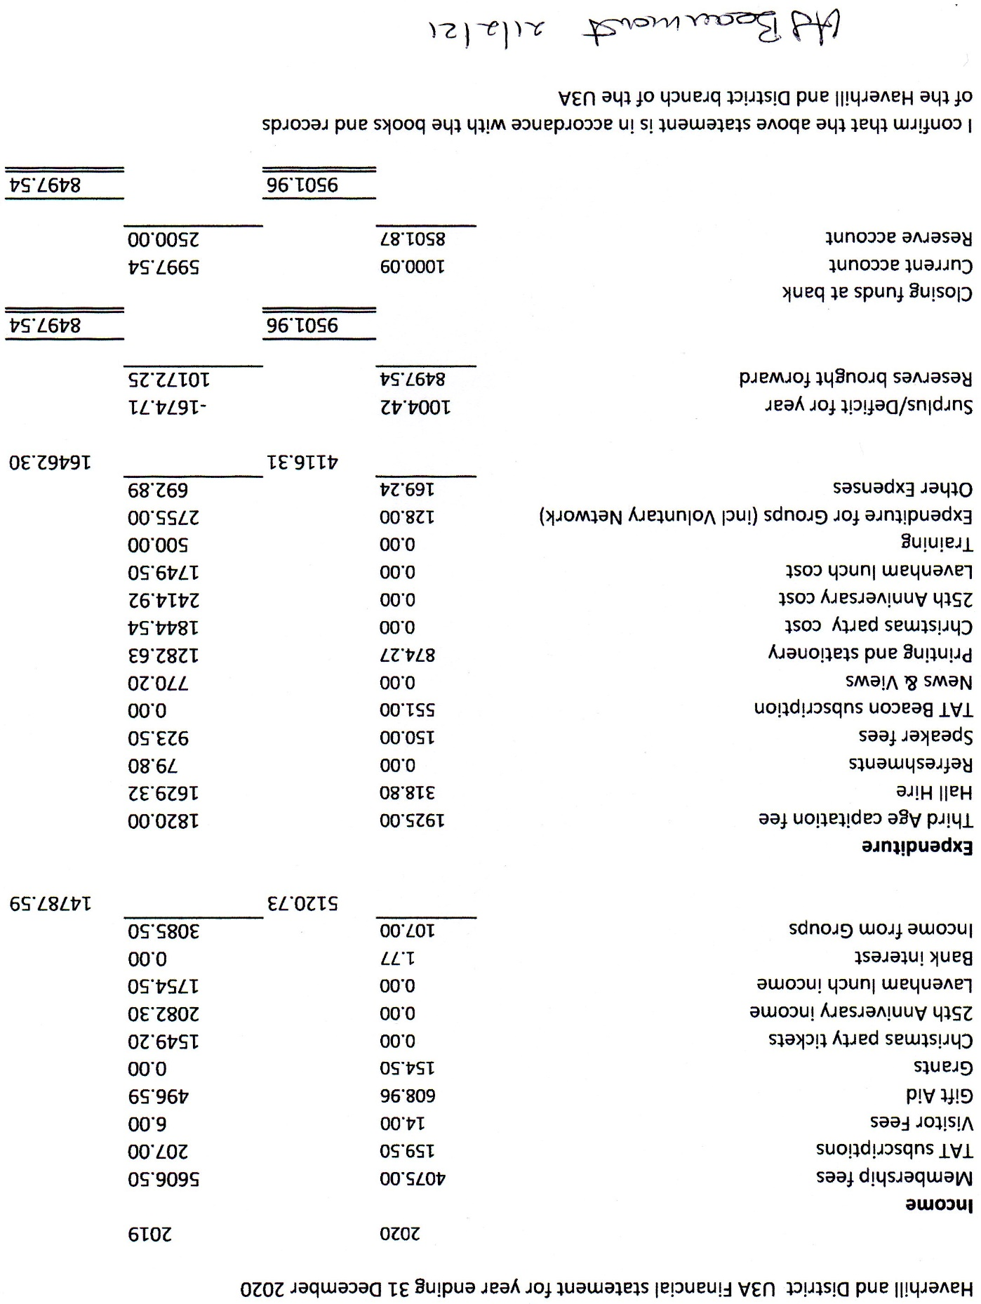

# Report from **Groups Co-ordinator**: PT, including comments from LM

**Report from Peter Tatam, Groups Co-ordinator 16th July 2021**

**Comments in green by Lesley Metcalfe, Chair.**

**Risk Assessments**

The basic u3a risk assessment template is adequate for use by all groups. The existing copy does mention government guidelines and social distancing, so I assume it will be amended as and when all restrictions are removed, which should be next Monday the 19th.

Social distancing ‘advice’ will remain for the foreseeable future.

Each group should retain their own risk assessments either electronically or as paper copies to be made available should the need arise at a future date. This would probably only be after an accident at an event or meeting.

Groups may need help filling them in. We need to check they do it and make available for all members to see (on website probably).

When covid restrictions are removed we will all be expected to use sensible caution to protect ourselves and others. Considering the age profile of our members I would be happy to maintain mask wearing indoors, so how does the rest of the committee feel? We will need to give some guidance to members before our first meeting at the Arts Centre.

Yes, masks indoors are advised but not enforced. Members will need to see a copy of the risk assessment before they arrive.

**Groups**

Some groups are already meeting, especially those that meet outdoors. Many are waiting on venues to re-open and to discover what restrictions, if any, are imposed. A venue that insists on social distancing will prevent some groups from proceeding. You can space out seating for many activities, but some groups rely on closer contact to play cards etc.

Groups that are already meeting will need their risk assessments asap. Others may need advice on how to continue. Perhaps a different venue or smaller groups meeting more often could be considered.

As each group notifies me that it intends to re-open, I am advising them of any members listed that have not renewed their membership. I have been asked if we will make them pay before September and I have stated that to be covered by the u3a insurance we have no other option. The reduced rate that we apply after the first six months is quite low compared to the full amount demanded by the WI etc. The committee should let me know if they will accept a alternative strategy.

I’m afraid everyone who joins in must be a member or our insurance will not cover them.

The website does not give prospective new members much information about groups and their activities. People are urged to sign up to a group before discovering what is on offer. I have asked leaders to compile a brief summary of what they do to be added to the site. If they cannot do so I have suggested sending it through so that I can add it. I still feel that a simple list of groups and what they offer would be better than the more complicated arrangement we have at present.

Good, I agree. The web team should work on this. Peter and Gerry can work together to sort out what is best for the Group Pages.

**Finances**

I am sorry that I am unable to contribute to the discussion regarding finances. We have, so far, had to work in an abnormal climate without meetings of groups or members. I am concerned that some of the new committee have had no experience of our Arts Centre meetings or the way in which groups operate and may be making judgements * from supposition rather than facts. The proposal that we use zoom to augment the meetings is flawed * as few members join currently via zoom and many of those would normally attend in person. The effort of simultaneous broadcasting of speakers * who will agree is unlikely to produce any significant increase in members participating on the day.*

Our finances are managed extremely well,* and in the past any reasonable expenditure agreed by the committee has been covered easily.* This will no doubt remain the case going forward and I see no reason to make significant changes.*

No judgements have been made yet. We are currently gathering the facts and asking for opinions.

TAT encourages the use of zoom. We should encourage and assist where we can.

Simultaneous broadcast is the way other groups are going and it is the future.

There will always be a limit to the number of members participating on the day. It is our job to ensure we have provision for everyone who pays a membership fee.

I have never doubted that the finances have been managed well. There is no question that expenses have always been met. However, it is important to realise the true measure of success is ‘money spent well’ not ‘lots of profit in the bank’. Well spent means ‘in support of our charitable aims’ as listed in the constitution.

I am NOT proposing significant changes. In fact, I used 2019 as a model. Balance went down by £2000 and I propose we do the same again.

Except this time, we should try not to subsidise the Christmas lunches etc but use the extra cash for promotions etc.